CMR COLLEGE OF ENGINEERING AND TECHNOLOGY
(Autonomous)
(NAAC Accredited with ‘A+’ Grade & NBA Accredited)
(Approved by AICTE, Permanently Affiliated to JNTU Hyderabad)
KANDLAKOYA, MEDCHAL ROAD, HYDERABAD-501401

IETE STUDENT FORUM EVENTS
REPORT
Academic Year
JULY 2024-JUNE 2025

- IETE Overview
The Institution of Electronics and Telecommunication Engineers (IETE) is a prestigious professional society in India that focuses on advancing electronics, telecommunications and IT. At CMR College of Engineering and Technology, the IETE Students’ Forum (ISF) functions under the Department of Electronics and Communication Engineering (ECE), serving as a gateway for students to expand their technical knowledge and innovative thinking.
The ISF provides a vibrant platform for ECE students to engage in hands-on learning through workshops, seminars, guest lectures, hackathons and project exhibitions. It emphasizes bridging academic learning with practical applications while encouraging research and innovation in emerging domains such as IoT, Artificial Intelligence, Embedded Systems, VLSI and Communication Technologies.
By being part of IETE, students gain invaluable exposure to current industry trends, strengthen their problem-solving skills and develop leadership and teamwork abilities essential for engineering professionals. The ECE Department, through IETE, fosters a spirit of curiosity and collaboration, motivating students to contribute to technological advancements that impact society.
The IETE Students’ Forum at CMRCET stands as a proud initiative, shaping students into competent, creative and future-ready engineers.
About IETE
- Founded in 1953, IETE promotes science and technology in electronics, telecom, IT and related fields via conferences, journals, workshops and student programs.
- Recognised as a Scientific and Industrial Research Organisation (SIRO) and a national eminence institution, it serves over 120,000 members through more than 60 centres in India and abroad.
- Key activities include technical meetings, symposia, publications such as the IETE Journal of Research and student forums (ISF) for skill development and industry exposure.
History of IETE
- 1953: Established on October 1 as the Institution of Telecommunication Engineers by visionary leaders to address post-independence telecom growth needs.
- 1960s-1970s: Expanded scope to include electronics; renamed Institution of Electronics and Telecommunication Engineers to cover emerging computers and IT domains.
- 1980s-1990s: Gained SIRO status from Government of India; launched journals, conferences and local centres to foster R&D and knowledge sharing.
- 2000s: Grew membership to 25,000+ corporate members and thousands of students; initiated student forums and international outreach.
- 2010s-Present: Played key role in telecom policy via roundtables for NTP-2011; now drives digital India goals with 120,000+ members and modern initiatives.
Role in Telecom Policy
- Conducted stakeholder roundtables for NTP-2011, advising on spectrum, broadband, rural connectivity and FDI to shape India’s telecom superpower vision.
- Hosts symposia like the 42nd Mid-Term on telecom paradigms, bridging industry, academia and regulators for policy-aligned R&D and standards.

- A Two-Day Workshop on SMART PHONES FOR SMART MINDS: APPLYING THEORY IN EVERYDAY DEVICES
(24TH & 25TH OCTOBER – 2025)
- Smartphones represent the perfect blend of electronics, communication, and computing — turning complex engineering theories into devices we use every day. This workshop aims to help students understand how classroom concepts come alive inside a smartphone through real-world applications and demonstrations.
- Purpose: To bridge the gap between theoretical learning and its practical implementation in modern mobile technology.
- Focus Areas: Communication systems, networking, signal processing and system fundamentals as applied in smartphones.
- Learning Tools: Interactive sessions, quizzes and demonstrations guided by engineers from Qualcomm. Through engaging, hands-on sessions, participants will explore what happens when a phone call is made, understand the principles of wireless connectivity and gain awareness about intellectual property rights in technology innovation. By the end of this workshop, students will have a deeper appreciation for how engineering principles shape the devices that define our daily lives, preparing them to think practically and innovatively in the field of electronics and communication.

DAY – 1 OF WORKSHOP
Day 1 of the “Smart Phones for Smart Minds” workshop at CMR College of Engineering and Technology unfolded as a dynamic convergence of theory and real-world technology, where students were introduced to the inner workings of modern smartphones powered by Qualcomm innovations and guided to see them not just as everyday gadgets but as sophisticated embedded systems integrating advanced processors, intelligent connectivity and AI-driven features that reflect the very concepts they study in their ECE curriculum. Expert-led sessions unpacked contemporary trends in mobile technology—including high-performance chipsets, efficient power management, enhanced imaging and seamless wireless communication—while interactive discussions and Q&A segments encouraged participants to question, reflect and relate these advancements to future career paths in mobile, embedded and communication domains, resulting in a learning environment that was both technically enriching and deeply motivating for aspiring engineers.
- https://www.instagram.com/p/DQMx6LHE7Cs/
- https://www.instagram.com/reel/DQWxubYCXTJ/
- https://www.instagram.com/p/DQM15_6khae/
- https://www.instagram.com/isf_cmrcet/p/DSroaH6iTxA/
- https://www.instagram.com/reel/DHtN4uDoVz2/

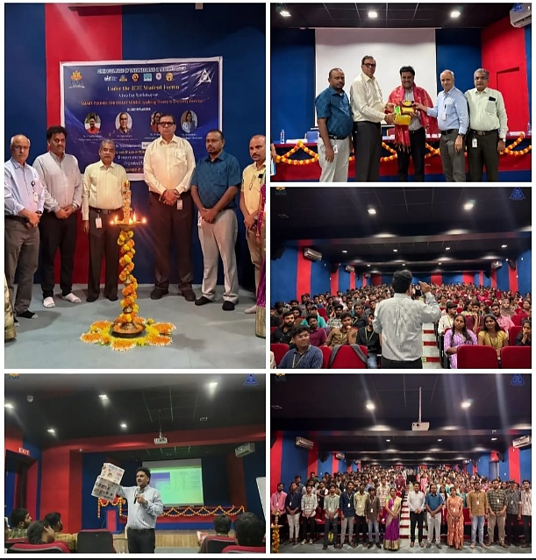

DAY – 2 OF WORKSHOP
Stories from work
In Qualcomm projects, an engineer rarely gets a perfectly defined problem; instead, a customer might say, “We need better battery life and a smoother camera experience” and the team has to translate that into concrete design changes in the chipset, software drivers and power management algorithms. Day to day, this involves reviewing hardware logs, debugging rare corner cases that only appear on a specific handset in a specific country, negotiating trade-offs between performance and thermal limits and coordinating with OEMs, camera vendors and network operators to ship a reliable product on time.
Camera fundamentals
When looking at camera fundamentals as a Qualcomm engineer, the focus is not just on taking a beautiful photo, but on how the image signal processor (ISP) and AI engines inside the SoC handle photons to pixels in milliseconds. Light passes through the lens and hits the sensor, where each photo site becomes a voltage that must be amplified, digitised, denoised, white-balanced, tone-mapped and sometimes processed with machine learning models for HDR, night mode, face detection and scene understanding—all while meeting power and latency constraints on a mobile device. This means understanding aperture, shutter speed, ISO and sensor size not just as photography terms, but as parameters that affect signal-to-noise ratio, dynamic range, autofocus behaviour, memory bandwidth and ultimately the ISP pipeline design on the chip. ​
Data communications and networking
From the Qualcomm side, data communication is about how bits move efficiently and reliably from your device to the world over 4G, 5G, Wi-Fi and beyond, all managed by the modem and RF subsystems tightly integrated with the application processor. At a conceptual level, the OSI or TCP/IP layers become very concrete: physical and MAC layers deal with modulation, coding and resource scheduling on the air interface; network and transport layers manage IP addressing, routing, congestion control and higher layers ensure your camera image or video stream reaches the cloud quickly and securely, even in a crowded network.

- ONE-WEEK FDP ON “Advanced Hardware Architectures for Image Processing using FPGA & ASIC Technologies”.

- DAY : 8-12-25
- Morning - FDP Inaugural Event & Overview of Image Processing Algorithms.
Image processing algorithms are techniques used to analyze, enhance and transform digital images. They include operations such as filtering, edge detection, segmentation, feature extraction and image restoration. These algorithms improve image quality, extract meaningful information and support applications in medical imaging, remote sensing, computer vision, pattern recognition and industrial inspection systems.
- Afternoon - Fundamentals of Image Processing & Python for Vision Applications.
covers how digital images are formed, enhanced and analyzed using operations like filtering, edge detection and segmentation. With Python libraries such as OpenCV and NumPy, it enables building practical computer vision applications including object detection, image recognition and real-world visual automation.

- DAY : 9-12-25
- MORNING - Static Timing Analysis (STA)
It is a method used in digital VLSI design to verify timing without simulation. It checks setup, hold, clock and path delays across all conditions, ensuring circuits meet performance, reliability and frequency requirements before fabrication. STA uses constraints, clocks and libraries to identify violations early in designs.
- Afternoon - Python programming for image and video processing
Python programming for image and video processing uses libraries like OpenCV, NumPy and Pillow to read, analyze and enhance visual data. It enables tasks such as image enhancement, edge detection, object recognition and real-time video analysis. Python’s simplicity and powerful tools make it widely used in computer vision, medical imaging, surveillance and AI-based applications.

- DAY – 10-12-25
- MORNING - Nanoscale Semiconductor Devices for Low-Power Biomedical Applications
Nanoscale semiconductor devices are tiny electronic components designed to operate with very low power. They are used in biomedical applications such as implantable sensors, wearable health monitors and medical diagnostics. These devices improve energy efficiency, reduce heat generation and enable reliable, long-term operation inside the human body.
- Afternoon - PYTHON- BASED IMAGE PROCESSING WORKFLOWS
Python-based image processing workflows use libraries such as OpenCV, NumPy, and scikit-image to acquire, preprocess, analyze and visualize images. Typical steps include image loading, enhancement, filtering, feature extraction and result interpretation. These workflows enable efficient development of computer vision applications in areas like medical imaging, remote sensing, automation and artificial intelligence systems.

- DAY – 11-12-25
- MORNING - Introduction to FPGA Design Flow Using AMD Vivado ML Edition
The FPGA design flow using AMD Vivado ML Edition involves creating hardware designs using HDL, simulating functionality, synthesizing logic and implementing the design on FPGA hardware. The tool provides an integrated environment for design entry, verification, optimization and bitstream generation, helping designers efficiently develop, test and deploy reliable FPGA-based digital systems.

- AFTERNOON - EMBEDDED SYSTEM DESIGN USING VITIS
Embedded System Design using Vitis focuses on developing hardware-accelerated applications on Xilinx platforms. It involves designing hardware in Vivado, creating software in Vitis, integrating processors and peripherals and programming on SoC or FPGA boards. This approach enables efficient application development, debugging and performance optimization for real-time embedded systems.

- DAY – 12-12-25
- MORNING - ASIC Design Flow Using Cadence EDA Tools – Hands-on Part I.
The ASIC design flow using Cadence EDA tools includes specification, RTL design, functional verification, synthesis, floor planning, placement, routing and timing verification. These tools help optimize performance, power and area while ensuring correct functionality, enabling reliable fabrication of complex integrated circuits.
- AFTERNOON - Cadence Tools Hands-on: Synthesis, Simulation & Layout.
Cadence Tools hands-on training covers the complete VLSI flow. It starts with RTL design and synthesis using Genus, followed by functional and timing simulation with Xcelium. Finally, it includes physical design and layout using Innovus, helping learners understand real-time chip implementation, verification and industry-oriented design practices.

- DAY – 13-12-25
- MORNING - Advancements in Hardware Architectures for Image Processing Applications.
Recent advancements in hardware architectures have improved the speed and efficiency of image processing systems. Technologies such as GPUs, FPGAs and ASICs enable parallel processing and low-power operation. These architectures support real-time image analysis, high-resolution data handling and are widely used in medical imaging, surveillance, autonomous systems and multimedia applications.

